|  |
| --- |
| [Pendleton Innovation] |
| D284 -Software Engineering |
| [CRM Requirements] |

|  |
| --- |
| [Trayvonious Pendleton]  8-30-2024  [Version XX] |

Contents

A. Introduction 3

A1. Introduction and Purpose Statement 3

A2. Overview of the Problems 3

A3. Goals and Objectives 3

A4. Prerequisites 3

A5. Scope 3

A6. Environment 3

B. Requirements 4

Business Requirements 4

User Requirements 4

Functional Requirements 4

Non-Functional Requirements 4

C. Software Development Methodology 4

C1. Advantages and Disadvantages 4

Advantages of the Agile Method 4

Disadvantages of the Agile Method 4

Advantages of {A Different Method} 4

Disadvantages of {A Different Method} 4

C2. Best suited 5

D. Create Two Representations of the Software Solution 5

Representation 1 5

Representation 2 5

E. Testing 6

Test Name 1 6

Test Name 2 7

Test Name 3 8

F. Sources 8

# Introduction

# A1. Introduction and Purpose Statement

At Pendleton Innovation, we highly recommend that MJ Logistics Gaming Company adopt our top-rated CRM solution, Pendleton CRM Pro. The primary purpose of Pendleton CRM Pro is to consolidate all contact and business information for MJ Logistics, enhance their reporting capabilities, and integrate seamlessly with other systems. The CRM system is designed to control access through role-based permissions, both on-site and off-site while ensuring robust security throughout. Additionally, Pendleton CRM Pro is fully scalable, allowing it to grow and evolve alongside your business. This document aims to provide detailed specifications on how Pendleton CRM Pro will be integrated into MJ Logistics Gaming Company’s operations.

# A2. Overview of the Problems

As MJ Logistics Gaming Company continues to grow, its current infrastructure has outpaced the existing tools, including spreadsheets and databases, leading to inefficiencies and reliance on manual processes. Pendleton CRM Pro addresses these challenges by providing a unified platform that automates workflows, enhances data accuracy, and enables comprehensive reporting. Importantly, it achieves all this while preserving the integrity of the company’s internal infrastructure as much as possible.

# A3. Goals and Objectives

Here are the goals and objectives of the Pendleton CRM Pro

Consolidate Customer Data: Create a database for all Customer and business information.

Streamline Sales Process: Automate and track sales cycles from beginning orders to order fulfillment.

Enhance Reporting: Advanced reporting tools that allow for real-time data visualization, custom reports, and a dashboard.

Ensure Scalability: Build a system that can grow with the company, accommodating a growing number of users and data.

Strengthen Security: Implement security measures that include role-based access controls to protect customer information.

# A4. Prerequisites

|  |  |  |  |
| --- | --- | --- | --- |
| Number | Prerequisite | Description | Completion Date |
| 1 | Infrastructure Readiness | Test the IT infrastructure to make sure it is capable of supporting Pendleton CRM Pro | 3/1/2025 |
| 2 | User Training | Develop and Deliver training for all user | 6/1/2025 |
| 3 | Data Migration | Migration of existing customer data to Pendleton CRM Pro | 6/1/2025 |
| 4 | Development | Finalize all custom features and integrations | 9/1/2025 |

# A5. Scope

* Included
  + Integration with existing systems (e.g., email, internal databases)
  + Development of core CRM features such as contact management, sales tracking, and reporting
  + Implement security features, including role-based access control and data encryption
* Not Included
  + Mobile application development
  + Accounting software
  + Project management

# A6. Environment

**Front-End Environment**

Pendleton CRM Pro will feature a web-based interface designed for compatibility with all major browsers, including Chrome, Firefox, Safari, and Edge. The interface will be user-friendly, focusing on intuitive navigation and accessibility to ensure that all users, regardless of technical expertise, can easily manage customer relationships and perform essential tasks. The front end will be responsive, ensuring optimal performance on both desktop and mobile devices. It will incorporate modern UI elements like dropdowns, data grids, and dashboards to enhance the user experience.

**Back-End Environment**

The back-end of Pendleton CRM Pro will run on a secure cloud-based server infrastructure, utilizing a relational database (e.g., PostgreSQL or MySQL) to manage and store customer data efficiently. The system will integrate with Pendleton Innovation’s active directory, providing seamless user authentication, role management, and centralized control over user permissions and access. This integration ensures only authorized users can access sensitive data, aligning with the company’s security protocols.

**Hosting and Service Level Agreements (SLAs)**

Pendleton CRM Pro will be hosted on a cloud platform (e.g., AWS, Azure, or Google Cloud) that offers high availability and scalability to meet the growing needs of MJ Logistics Gaming Company. The hosting provider will provide a robust SLA, guaranteeing 99.9% uptime to ensure the CRM system is always accessible. The SLA will also cover support response times, addressing any issues promptly to minimize downtime.

* **Connectivity and Outages**: The hosting environment will include multiple redundancies, such as data replication across different geographic locations, to mitigate the risk of connectivity outages. In the event of an outage, the SLA will specify the maximum acceptable downtime and the steps that will be taken to restore service quickly.
* **Upgrades and Custom Development**: Pendleton CRM Pro will have a structured upgrade path with regular updates to improve functionality, security, and performance. Users can refuse upgrades, if necessary, particularly if custom developments could be impacted. Custom development requests will be handled through a dedicated support team, which will handle custom development requests, ensuring that any changes or enhancements are thoroughly tested before being implemented in the production environment.

**Support and Maintenance**

The cloud hosting provider will offer 24/7 support for Pendleton CRM Pro, with multiple support tiers to address different types of issues, ranging from minor bugs to critical system failures. Regular maintenance windows will be scheduled outside of peak usage hours to minimize disruptions, and all maintenance activities will be communicated to users in advance. The maintenance plan will include routine security patches, database optimization, and performance monitoring to ensure the system remains stable and secure.

**Testing Environment**

Pendleton CRM Pro will utilize a separate testing environment before deploying any changes or upgrades to the production environment. This environment will replicate the production setup, allowing for thorough testing of new features, custom developments, and upgrades. By using this testing environment, MJ Logistics Gaming Company can ensure that any changes will not disrupt existing operations or negatively impact system performance.

# Requirements

## Business Requirements

**Reporting:** Pendleton CRM Pro will feature an advanced reporting module that supports both predefined and customizable reports. The system will allow users to create detailed dashboards and summary reports, with drill-down capabilities to view underlying data. Reports can be filtered, formatted, and queried based on user needs, with options to save reports and reuse filters for future access. Additionally, the system will support historical data reporting, enabling users to access their department or function and enhancing security and usability.

## User Requirements

**OS and Browser Support:** Pendleton CRM Pro will be built on a scalable cloud-based infrastructure capable of supporting 2000 users, with dynamic resource allocation to maintain high performance even during peak usage periods. The system will be optimized for compatibility with the latest versions of Chrome, Firefox, Microsoft Edge, Safari, and mobile operating systems like iOS and Android. This ensures that users can access the CRM seamlessly from any device or platform, maintaining consistent performance and user experience across all supported environments.

## Functional Requirements

**Ticketing System:** The Sales Tracking module in Pendleton CRM Pro will act as a central hub for recording all visits and meetings with stakeholders. The system will integrate seamlessly with MS Exchange and Outlook, allowing for both one-way and two-way communication to sync calendar events and emails. A built-in ticketing system will enable users to log interactions with stakeholders, including follow-up actions and outcomes. It will also support data export and re-import features, ensuring that any external processing or analysis can be done with minimal risk of data loss or errors. Validation rules will be enforced during the import process to maintain data integrity.

## Non-Functional Requirements

**Forecasting**: Pendleton CRM Pro will provide advanced forecasting tools to help managers predict sales and revenues. The forecasting capabilities will support currency adjustments for foreign sales, baselining, and manager adjustments for better control over sales expectations. Machine Forecasting and Sales Distribution system will leverage machine forecasting techniques to predict sales distribution and adjust forecasts based on historical data and trends. The Forecast Periods and Product Forecasting system will allow for defining forecast periods and managing product-specific forecasts, helping managers plan and allocate resources effectively.

# Software Development Methodology

*.*

# C1. Advantages and Disadvantages

## Advantages of the Agile Method

* Advantages of Agile:
  + Flexibility: Agile allows for iterative development, making it easier to adapt to changing requirements as the project progresses.
  + Continuous Feedback: Agile promotes regular feedback from stakeholders, ensuring that the project remains aligned with business needs
  + Early Detection of Issues: Frequent testing and reviews help identify and resolve issues early in the development cycle

## Disadvantages of the Agile Method

* Disadvantages of Agile:
  + Less Predictability: The iterative nature of Agile can lead to changes in scope, making it more challenging to predict project timelines and costs.
  + Potential for Scope Creep: Without strict controls, Agile projects can experience scope creep, leading to delays and increased costs
  + Require High User Involvement: Agile requires ongoing stakeholder involvement, which may be challenging for some organizations.

## Advantages of {A Different Method}

* Advantages of Waterfall:
  + Structured and Predictable: Waterfall’s linear approach makes it easier to plan and predict project timelines and cost
  + Clear Milestones: waterfall provides clear stages and milestones, making tracking progress and managing resources easier.
  + Easier Management of Fixed Requirements: waters are well-suited for projects with well-defined and unchanging requirements

## Disadvantages of {A Different Method}

* Disadvantages of Waterfall:
  + Inflexibility: Waterfall only easily accommodates changes once the project is underway.
  + Delayed Feedback: Testing and feedback occur late in the process, making it harder to address issues that arise during development.
  + Challenges with Changing Requirements: Waterfall is unsuited for projects where requirements may evolve.

# C2. Best suited

Agile is better suited for Pendleton CRM Pro because it allows for iterative development and continuous improvement, which is essential given the evolving nature of the company’s requirements. For example, the sales tracking module can be developed incrementally, with regular feedback from the sales team to ensure that it meets their specific needs. Agile flexibility will also allow the project to adapt to any changes in business processes or customer requirements, ensuring that the final product is aligned with the company’s goals.

# Create Two Representations of the Software Solution

## Representation 1

This flowchart illustrates the process of capturing, storing, and managing customer data within Pendleton CRM Pro. It starts with data entry by the user, followed by data validation storage in the central database, and retrieval for reporting and analysis.

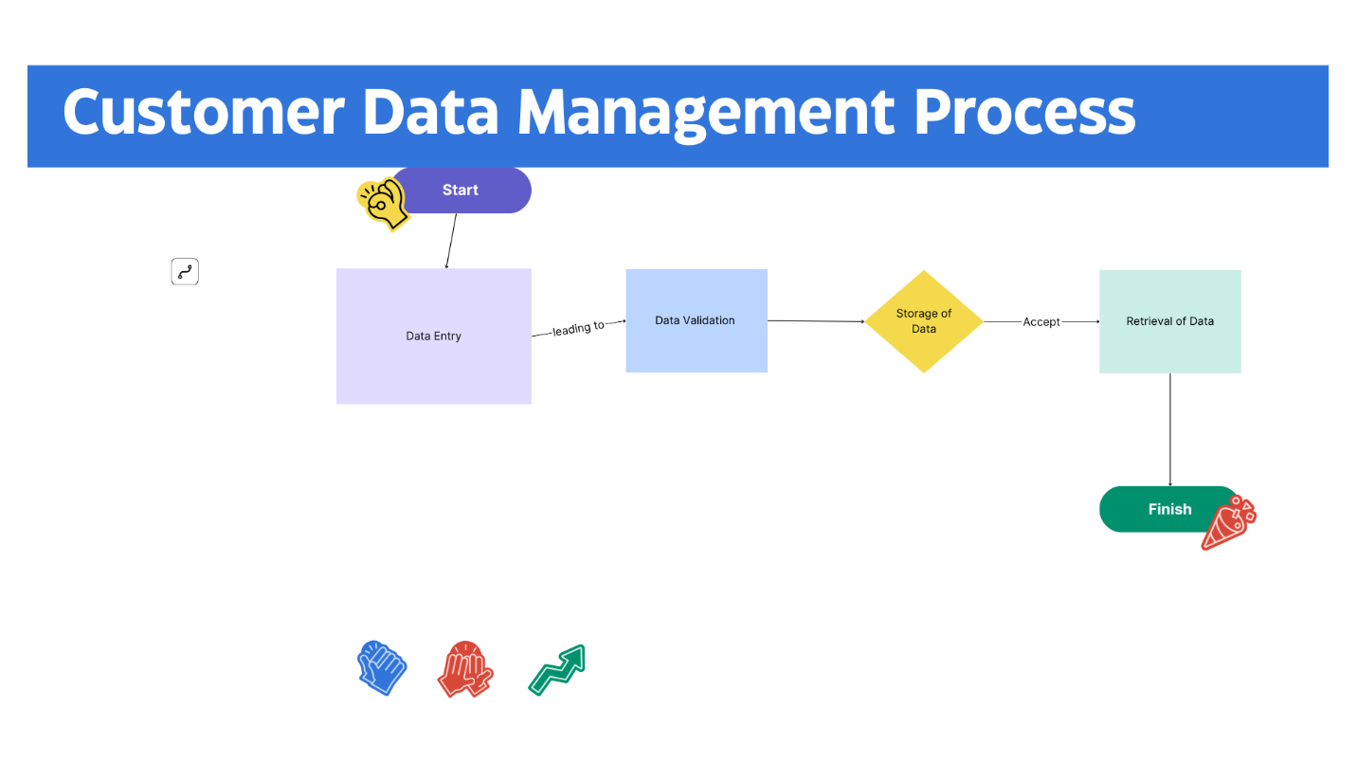

## Representation 2

This Storyboard depicts the different components of the sales tracking module in Pendleton CRM Pro. It shows how users interact with the system to manage leads, track sales activities, and generate reports.

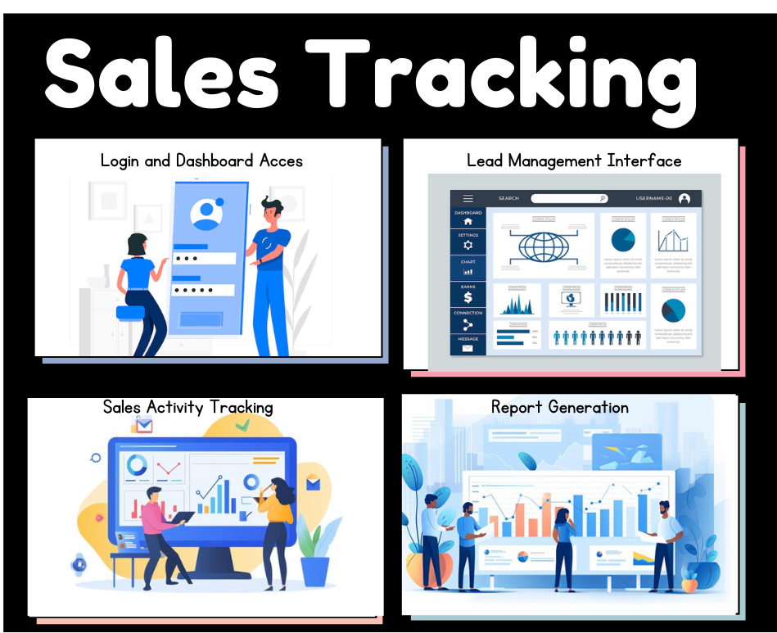

# Testing

# Test Name 1

|  |
| --- |
| Requirement to be tested: Customer Data Entry  The system must allow for accurate entry and storage of customer data. |
| Preconditions: Conditions that must be present before the test case can successfully run.:  The user is logged into Pendleton CRM Pro  The Customer Management module is accessible  Necessary permissions are granted to the user for data entry |
| Steps: The steps the tester must execute to test the feature.   1. Log in to Pendleton CRM Pro 2. Navigate to the Customer Management module 3. Click on Add New Customer 4. Enter new customer details 5. Save the entry |
| Expected results: Expected results and any side effects such as updating a database, writing to a file, etc.:  Customer data should be accurately saved and be retrievable from the system.  The system should allow retrieval of the customer details without any data corruption or loss. |
| Pass/Fail: Explain why the test case passed or failed. The results can be compiled and used to determine if the application is ready for delivery or release.  The test passes if the data is saved correctly and can be retrieved without errors, and all the fields display correctly. |

# Test Name 2

|  |
| --- |
| Requirement to be tested: Sales Activity Logging:  The system must log all sales activities. |
| Preconditions: Conditions that must be present before the test case can successfully run.  Sales data is available in the system.  The user has access to the Sales Tracking module and the necessary permissions to log activities. |
| Steps: The steps the tester must execute to test the feature.   1. Log in to Pendleton CRM Pro 2. Navigate to the Sales Tracking module 3. Enter a new sales activity 4. Select any follow-up actions required and assign a due date 5. Click “Save” to record the activity 6. Verify that the activity is recorded in the log |
| Expected results: Expected results and any side effects such as updating a database, writing to a file, etc.  The sale activity should be accurately recorded in the log, with all entered details displayed correctly. The activity should be associated with the correct customer/lead. Any follow-up actions should be properly scheduled in the system calendar. |
| Pass/Fail: Explain why the test case passed or failed. The results can be compiled and used to determine if the application is ready for delivery or release.  The test passes if the activity is logged with all details intact, is associated with the correct entities, and follow-up actions are correctly scheduled.  The test fails if there are discrepancies in the recorded details, the activity is not logged, or follow-up actions are not properly scheduled. |

# Test Name 3

|  |
| --- |
| Requirement to be tested: Report generation  The system must generate accurate sales reports |
| Preconditions: Conditions that must be present before the test case can successfully run.  Sales data is available in the system  The user has access to the Reports module with the necessary permissions.  The data set to be reported on is up-to-date and accurate. |
| Steps: The steps the tester must execute to test the feature.   1. Log in to Pendleton CRM Pro 2. Navigate to the Reports module. 3. Click on “Create New Report.” 4. Select the type of report to generate. 5. Apply relevant filters such as Date Range, sales Rep, Lead Status, and Product Line. 6. Click on Generate Report. 7. Review the generated reports to ensure all data is accurate and reflects the selected filters. 8. Save and export the report. 9. Download the exported report and verify that all data is accurate. |
| Expected results: Expected results and any side effects such as updating a database, writing to a file, etc.  The report should be generated with all data accurately displayed according to the applied filters.  The saved report should be retrievable in the Reports module.  The exported report should match the on-screen report exactly, without any data loss or formatting issues. |
| Pass/Fail: Explain why the test case passed or failed. The results can be compiled and used to determine if the application is ready for delivery or release.  The test passes if the report is accurate and exported; it fails if there are errors in the data or export process. |